Little SPARK: Simple Play Adaptations to Reference for Kids

Giant Alphabet Stampers Set – Lower Case
Description: | Image:
The stamps are labeled for quick identification. Each 3" diameter letter stamp features an easy grip handle, with see-thru top for easy placement.  Warning: Choking Hazard - Small Parts. Not for children under 3 years. | 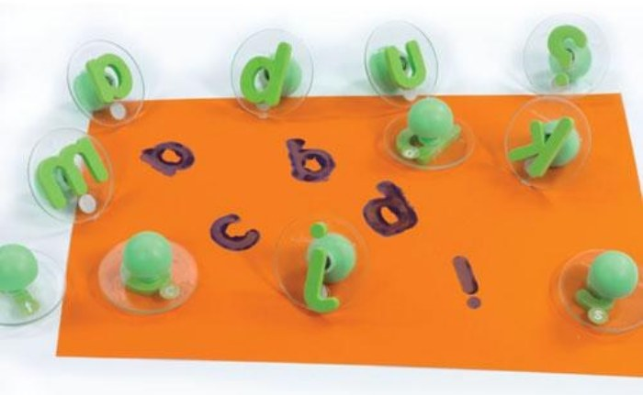

Who Might Benefit?
Those who have trouble holding writing tools, experience motor challenges with letter formation, enjoy/respond to sensory input, and show interest in “writing”.

Why Use?
Provides an opportunity to form lower case letters with ink or paint, practice “writing” letters, and engage in art activities that include letters.
Instructions for Use: | Adaptation Ideas:
Environmental Considerations  - Consider a designated area for stamping with ink or paint which might include an easy to clean mat or a cookie sheet.  Positioning & Alternate Positioning  - Use in any position; seated, standing, on the floor, with a slanted surface, vertical plane or any solid, flat surface.  Basic Play/Use  - Provide ink or paint, paper and stamps and allow children to create then talk about it.  Extended Play/Use  - Provide laminated cards with letter sequences, words, or the child's name so they can match, practice locating letters, and stamp them in order.  Play/Use with Others  - Pair children and show them how to form a Tic Tac Toe Grid on paper. Encourage them to choose a letter to play. | Build It Up  - Build up stamp handles with Wikki Stix or rubber bands.  Simplify It  - Offer only a few letters at a time, perhaps starting with letters of the child's name.  Stabilize It  - Tape down paper that the child is stamping or clamp it onto an easel.  Contain It  - Place paper, paint, ink pads and stamps on a rimmed cookie sheet or box lid.  Add Sensory Cues  - Add textures to the handles of the stamps.  Communication Support  - Provide a paper-based communication board with alphabet letters and activity related words.  DIY Alternatives  - During outdoor play use stamp with water on a painted surface and watch the letters “disappear” as the water marks evaporate.

Words to Encourage Play/Use
Pick  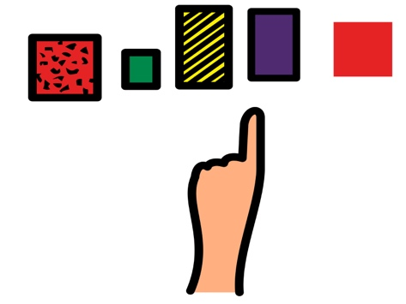 | Find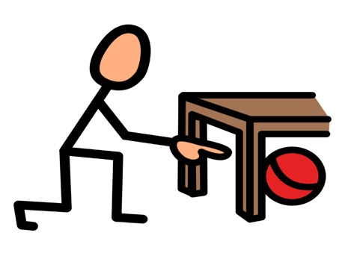 | Push 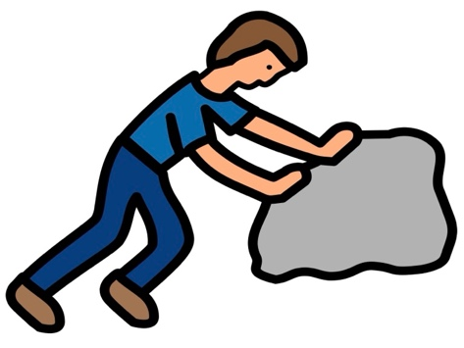
Hold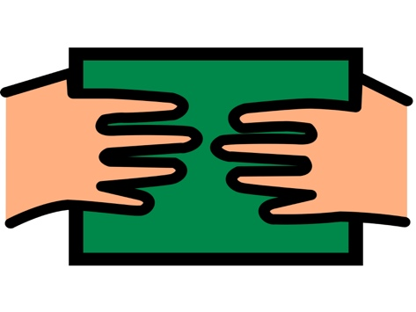 | Ready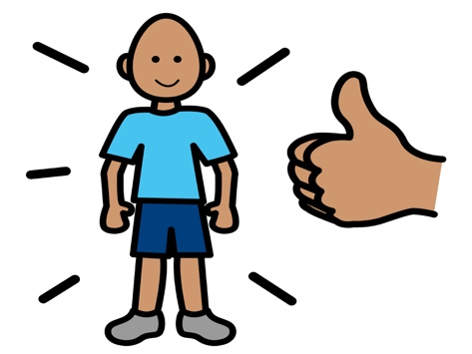 | Help 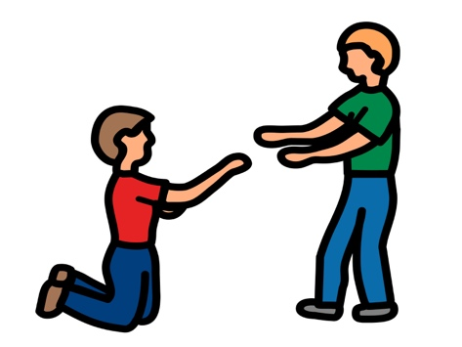
More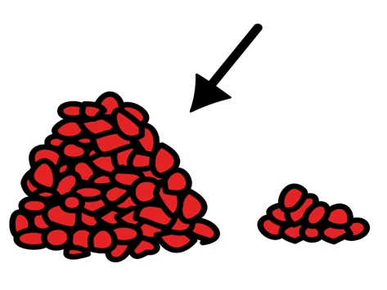 | Done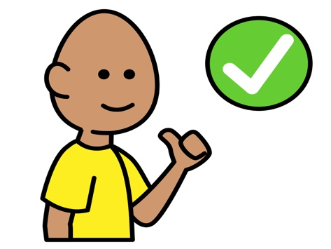 | Share  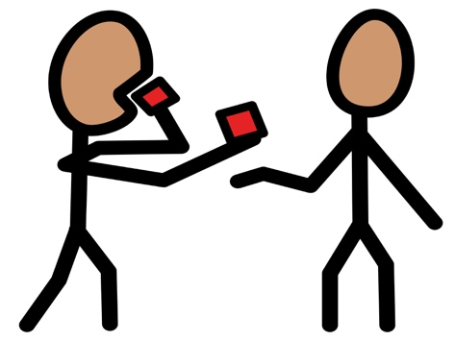
*”Adaptations” adapted from: Haugen’s Modes for Adapting Toys based on materials from the "Let's Play" Project at the University of Buffalo
PCS is a trademark of Tobii Dynavox, LLC. All rights reserved. Used with permission.

